7/17/2026
David John

Monitoring Stack
Grafana, Prometheus & Node exporter

Table of Contents
CHAPTER 1: INTRODUCTION 4
1.1 Purpose of the Document 4
1.2 Background 4
1.3 Relevance to Security Operations (SOC) 5
1.4 Project Objectives 5
1.5 Overview of the Monitoring Stack 6
1.5.1 Node Exporter 6
1.5.2 Prometheus 7
1.5.3 Grafana 7
1.6 Monitoring Architecture 8
1.7 Monitoring Workflow 9
1.8 Monitoring Stack Responsibilities 9
1.9 Expected Outcome 9
CHAPTER 2: SYSTEM REQUIREMENTS AND PREREQUISITES 10
2.1 Overview 10
2.2 Hardware Requirements 10
2.3 Software Requirements 11
2.4 Network Requirements 11
2.5 Required Knowledge 12
2.6 Required Permissions 12
2.7 Software Components 12
CHAPTER 3: NODE EXPORTER INSTALLATION AND CONFIGURATION 14
3.1 Introduction 14
3.2 Objectives 14
3.3 Installation Procedure 14
Step 1: Create a Dedicated Node Exporter User 14
Step 2: Navigate to the Temporary Directory 15
Step 3: Download Node Exporter 16
Step 4: Extract the Archive 16
Step 5: Enter the Extracted Directory 17
Step 7: Create a Systemd Service 18
Step 8: Reload Systemd 19
Step 9: Enable the Service 19
Step 10: Start the Service 19
Step 11: Verify the Service Status 20
Step 12: Verify Metric Exposure 20
CHAPTER 4: PROMETHEUS INSTALLATION AND CONFIGURATION 22
4.1 Introduction 22
4.2 Objectives 22
4.3 Installation Procedure 22
Step 1: Create a Dedicated Prometheus User 22
Step 2: Create the Required Directories 23
Step 3: Navigate to the Temporary Directory 24
Step 4: Download Prometheus 24
Step 5: Extract the Archive 24
Step 6: Navigate to the Extracted Directory 25
Step 7: Install the Prometheus Binaries 25
Step 8: Copy Console Files 26
Step 9: Copy the Default Configuration File 26
Step 10: Assign Ownership 27
4.4 Configure Prometheus 27
Step 11: Edit the Configuration File 27
4.5 Validating the Configuration 29
Step 12: Validate the Configuration File 29
4.6 Creating the Prometheus Service 29
Step 13: Create the Systemd Service 29
Step 14: Reload the Systemd Manager 30
Step 15: Enable the Prometheus Service 31
Step 16: Start the Prometheus Service 31
Step 17: Verify the Service Status 31
4.7 Verifying the Prometheus Deployment 31
Step 18: Access the Prometheus Web Interface 31
Step 19: Verify the Monitoring Targets 32
Step 20: Verify Metric Collection 33
Chapter 5: Installing and Configuring Grafana 35
5.1 Objective 35
5.2 Installing Grafana 35
5.3 Starting the Grafana Service 36
5.4 Accessing the Grafana Web Interface 36
5.5 Configuring Prometheus as a Data Source 37
5.6 Creating the Monitoring Dashboard 38
5.7 Dashboard Verification 41
5.8 Summary 41
Chapter 6 42
Conclusion 42

CHAPTER 1: INTRODUCTION

1.1 Purpose of the Document
This document provides a comprehensive, step-by-step guide for deploying and configuring a Linux system monitoring solution using Node Exporter, Prometheus, and Grafana on a Kali Linux virtual machine.
The guide covers the complete implementation process, beginning with the installation and configuration of Node Exporter, followed by Prometheus, and finally Grafana for data visualization and dashboard creation. By following the procedures outlined in this document, an administrator or analyst should be able to successfully deploy the monitoring stack, verify its functionality, and build dashboards for real-time monitoring of system performance.
The document is intended for system administrators, Security Operations Center (SOC) analysts, IT support personnel, and other technical staff responsible for monitoring the health, availability, and performance of Linux systems.

1.2 Background
Modern IT environments rely heavily on continuous monitoring to ensure systems remain available, stable, and performant. Monitoring enables administrators and security teams to observe system behaviour in real time, detect abnormal resource utilization, identify performance bottlenecks, and respond to potential issues before they affect business operations.
A monitoring platform collects operational metrics from servers and infrastructure, stores them over time, and presents them through dashboards that allow users to quickly assess system health.
The monitoring solution implemented in this guide consists of three open-source tools:
- Node Exporter – Collects system and hardware metrics from the Linux host.
- Prometheus – Retrieves, stores, and queries the collected metrics.
- Grafana – Presents the stored metrics through customizable dashboards and visualizations.
Together, these tools provide a lightweight, scalable, and highly flexible monitoring platform suitable for both laboratory environments and production deployments.

1.3 Relevance to Security Operations (SOC)
Although Prometheus and Grafana are primarily infrastructure monitoring tools rather than security monitoring platforms, they play an important supporting role within a Security Operations Center (SOC).
Infrastructure metrics provide operational context that can assist analysts during incident investigation and system monitoring. For example, sudden increases in CPU utilization, memory consumption, disk activity, or network traffic may indicate application issues, configuration problems, denial-of-service conditions, or other operational events that warrant investigation. These metrics are most useful when combined with logs, alerts, and other security telemetry rather than interpreted as direct evidence of an attack.
By establishing normal performance baselines, SOC analysts can more easily recognize unusual system behaviour and correlate infrastructure events with information from other monitoring or security tools.

1.4 Project Objectives
The primary objective of this implementation is to deploy a centralized monitoring solution capable of collecting, storing, querying, and visualizing Linux system performance metrics.
Specific objectives include:
- Deploy Node Exporter to collect operating system metrics.
- Configure Prometheus to periodically scrape and store metrics from Node Exporter.
- Deploy Grafana and integrate it with Prometheus as a data source.
- Create monitoring dashboards for visualizing key system performance indicators.
- Validate that the monitoring stack operates correctly and provides real-time system visibility.
Upon successful completion, the monitoring environment will provide visibility into metrics including:
- CPU utilization
- Memory utilization
- Disk usage
- Filesystem usage
- Network traffic
- System uptime
- Running processes
- System load

1.5 Overview of the Monitoring Stack
The monitoring solution consists of three independent components, each performing a specific function within the overall monitoring architecture.

1.5.1 Node Exporter
Node Exporter is an open-source exporter designed for Prometheus. It runs as a lightweight service on the monitored Linux system and is responsible for collecting operating system and hardware performance metrics.
The exporter gathers information from the Linux kernel and system interfaces, exposing these metrics through an HTTP endpoint (default port 9100) in a format understood by Prometheus.
Examples of collected metrics include:
- CPU statistics
- Memory utilization
- Disk usage
- Filesystem statistics
- Network interface statistics
- Running processes
- System load averages
- System uptime
Node Exporter does not store any metrics. Its sole responsibility is to expose current system information whenever Prometheus requests it.

1.5.2 Prometheus
Prometheus is an open-source systems monitoring and alerting toolkit that serves as the central monitoring engine within the monitoring stack.
Prometheus periodically retrieves (scrapes) metrics from Node Exporter, stores them as time-series data, and provides a powerful query language known as PromQL for analyzing both real-time and historical metrics.
Unlike systems that rely on monitored devices pushing data to a central server, Prometheus follows a pull model, where it initiates metric collection by contacting configured targets at regular intervals.
Prometheus provides:
- Metric collection
- Time-series data storage
- Metric querying using PromQL
- Target monitoring
- Alerting capabilities (when configured)
By default, Prometheus provides a web interface accessible on port 9090.

1.5.3 Grafana
Grafana is an open-source visualization platform used to present monitoring data through interactive dashboards.
Grafana does not collect metrics directly. Instead, it connects to Prometheus as its data source and retrieves metrics whenever a dashboard is loaded or refreshed.
Grafana supports numerous visualization types including:
- Stat panels
- Gauges
- Time-series charts
- Bar charts
- Tables
- Heatmaps
These visualizations enable administrators and analysts to quickly interpret system performance and identify abnormal conditions.
Grafana's web interface is accessible by default on port 3000.

1.6 Monitoring Architecture
The interaction between the monitoring components is illustrated below.
Linux Host
│
│
Collects System Metrics
Node Exporter
Port 9100
│
│
Prometheus Scrapes Metrics
Prometheus
Port 9090
│
Grafana Queries Metrics
Grafana
Port 3000
System Administrator
/ SOC Analyst

1.7 Monitoring Workflow
The monitoring process follows a pull-based architecture and consists of the following sequence:
- Node Exporter continuously exposes system performance metrics collected from the Linux operating system.
- Prometheus periodically scrapes the exposed metrics through the Node Exporter HTTP endpoint.
- Prometheus stores the collected information within its internal time-series database.
- Grafana queries Prometheus whenever dashboard panels require data.
- Grafana renders the queried metrics as visual dashboards that provide real-time visibility into system performance.
- Administrators and SOC analysts use these dashboards to monitor system health, investigate abnormal behaviour, and support operational decision-making.

1.8 Monitoring Stack Responsibilities
Component | Primary Responsibility | Default Port
Node Exporter | Collects and exposes Linux operating system metrics | 9100
Prometheus | Scrapes, stores, and queries time-series metrics | 9090
Grafana | Visualizes metrics through dashboards and panels | 3000

1.9 Expected Outcome
Upon successful completion of this implementation, the monitoring stack will provide a centralized platform for observing the operational state of the monitored Linux system.
The resulting Grafana dashboard will present real-time performance metrics including CPU utilization, memory usage, disk usage, network activity, uptime, running processes, and other selected system indicators. These dashboards improve operational awareness and support administrators and SOC analysts in monitoring system health, identifying trends, and responding more effectively to performance issues.

CHAPTER 2: SYSTEM REQUIREMENTS AND PREREQUISITES

2.1 Overview
Before deploying the monitoring stack, it is important to ensure that the host environment meets the minimum hardware and software requirements. Proper preparation minimizes installation issues and ensures that all components operate reliably throughout the deployment process.
This implementation was carried out using a Kali Linux virtual machine hosted on Oracle VirtualBox. While the procedures described in this document are based on that environment, the monitoring stack can also be deployed on other Linux distributions with minimal modifications.

2.2 Hardware Requirements
The following minimum hardware specifications are recommended for a single-host deployment.
Component | Minimum Requirement | Recommended
Processor | Dual-Core CPU | Quad-Core CPU or higher
RAM | 4 GB | 8 GB or more
Storage | 30 GB | 60–80 GB
Network | Internet Connectivity | Stable Broadband Connection
Explanation
Processor
A dual-core processor is sufficient for a laboratory deployment. However, allocating additional CPU cores improves Grafana dashboard responsiveness and Prometheus query performance.
Memory (RAM)
Node Exporter consumes very little memory, while Prometheus and Grafana require additional resources for metric storage and dashboard rendering. For a virtual machine hosting all three services, allocating at least 4 GB of RAM is recommended, with 8 GB preferred for smoother performance.
Storage
The monitoring stack stores metric data locally within Prometheus. As metric retention increases, storage requirements also grow. For laboratory environments, a virtual disk of 60–80 GB provides sufficient capacity for the operating system, monitoring software, and collected metrics.

2.3 Software Requirements
The deployment environment used for this implementation is summarized below.
Software | Version / Recommendation
Operating System | Kali Linux (latest stable release at time of deployment)
Virtualization Platform | Oracle VirtualBox 7.x
Terminal | Bash
Package Manager | APT
Browser | Firefox or Chromium
User Account | User with sudo privileges
Operating System
The deployment was performed using Kali Linux because it provides a stable Debian-based environment and includes the required package management utilities. Since Node Exporter, Prometheus, and Grafana are Linux-native applications, the procedures described in this document can generally be adapted to other Debian-based distributions with minimal changes.
Virtual Machine
Rather than installing directly on physical hardware, the monitoring environment was deployed inside an Oracle VirtualBox virtual machine. Virtualization provides an isolated environment for experimentation, simplifies recovery through snapshots (where appropriate), and allows the monitoring stack to be tested without affecting the host operating system.

2.4 Network Requirements
The virtual machine should have:
- Internet connectivity for downloading packages and software.
- A functioning network adapter (NAT or Bridged mode).
- Ability to communicate over the following TCP ports:
Service | Port | Purpose
Node Exporter | 9100 | Exposes Linux system metrics
Prometheus | 9090 | Prometheus Web Interface
Grafana | 3000 | Grafana Dashboard Interface
Note: When monitoring additional systems, firewall rules should permit Prometheus to access the Node Exporter endpoint on the monitored hosts.

2.5 Required Knowledge
Although not mandatory, familiarity with the following topics will make the deployment process easier:
- Basic Linux command-line operations
- File and directory navigation
- Editing files using Nano or Vim
- Basic networking concepts
- System services (systemd)
- Understanding of HTTP ports

2.6 Required Permissions
The user performing the installation should have:
- A user account with sudo privileges.
- Permission to install software packages.
- Permission to create system services.
- Permission to modify configuration files.
- Permission to restart system services.

2.7 Software Components
The monitoring stack consists of three primary software components.
Component | Purpose
Node Exporter | Collects Linux operating system metrics.
Prometheus | Collects, stores, and queries metrics.
Grafana | Displays metrics through dashboards.
Each component depends on the previous one:

Linux System
Node Exporter
Prometheus
Grafana
This dependency explains why the installation order followed in this guide is:
- Node Exporter
- Prometheus
- Grafana

CHAPTER 3: NODE EXPORTER INSTALLATION AND CONFIGURATION

3.1 Introduction
Node Exporter is the first component deployed in the monitoring stack. Its primary role is to collect system and hardware metrics from the Linux machine and make them available through an HTTP endpoint that Prometheus can read. Unlike Prometheus, Node Exporter does not store any information. Instead, it continuously gathers real-time metrics such as CPU usage, memory utilisation, disk activity, network statistics, and system uptime whenever they are requested. By default, these metrics are exposed on TCP port 9100, allowing Prometheus to collect them at regular intervals.

3.2 Objectives
At the end of this chapter, the administrator should be able to:
- Install Node Exporter.
- Configure Node Exporter to run as a system service.
- Verify that the exporter starts successfully.
- Confirm that system metrics are accessible through the web interface.
- Prepare the system for Prometheus integration.

3.3 Installation Procedure

Step 1: Create a Dedicated Node Exporter User
Purpose
For security reasons, Node Exporter should not run using the root account. Instead, a dedicated system user with no login privileges is created. This follows the principle of least privilege, ensuring the service has only the permissions required to perform its function.
Command
sudo useradd --no-create-home --shell /bin/false node_exporter
Command Breakdown
Parameter | Description
sudo | Executes the command with administrative privileges.
useradd | Creates a new user account.
--no-create-home | Prevents creation of a home directory because the service does not require one.
--shell /bin/false | Prevents interactive login using this account.
node_exporter | Name assigned to the service account.
Verification
Verify that the account was successfully created.
id node_exporter
Expected Output
uid=1001(node_exporter)
gid=1001(node_exporter)
groups=1001(node_exporter)
This confirms that the dedicated service account exists.

Step 2: Navigate to the Temporary Directory
Purpose
The /tmp directory is commonly used for temporary downloads and installation files. Downloading the Node Exporter archive into this location keeps the user's home directory organized.
Command
cd /tmp
Verification
Confirm the current working directory.
pwd
Expected Output
/tmp

Step 3: Download Node Exporter
Purpose
Download the latest stable Node Exporter release from the official GitHub repository.
Incorrect Attempt
The following command was initially attempted:
wget https://github.com/prometheus/node_exporter/releases/latest/download/node_exporter-*.linux-amd64.tar.gz
This resulted in:
ERROR 404: Not Found.
Explanation
The wget utility does not interpret wildcard characters (*) within HTTP URLs. As a result, the requested file does not exist, causing GitHub to return a 404 Not Found error.
Correct Command
Specify the complete release filename:
wget https://github.com/prometheus/node_exporter/releases/download/v1.11.1/node_exporter-1.11.1.linux-amd64.tar.gz
Note: Replace v1.11.1 with the latest stable release available when performing the installation.
Verification
Confirm that the archive has been downloaded.
ls
Expected output should include:
node_exporter-1.11.1.linux-amd64.tar.gz

Step 4: Extract the Archive
The downloaded archive is compressed using the .tar.gz format and must be extracted before installation.
Command
tar xvf node_exporter-1.11.1.linux-amd64.tar.gz

Command Breakdown
Option | Description
x | Extract archive contents
v | Display extracted files (verbose mode)
f | Specifies the archive file
Expected Output
node_exporter-1.11.1.linux-amd64/
LICENSE
NOTICE
node_exporter

Step 5: Enter the Extracted Directory
Move into the extracted directory containing the Node Exporter binary.
Command: cd node_exporter-1.11.1.linux-amd64
Verify the contents.
ls
Expected output:
LICENSE
NOTICE
node_exporter

Step 6: Install the Binary
Copy the executable into /usr/local/bin, a standard directory used to store locally installed applications that are available system-wide.
Command
sudo cp node_exporter /usr/local/bin/
Why /usr/local/bin?
Linux searches directories listed in the system's PATH environment variable when executing commands. Since /usr/local/bin is included in the PATH, Node Exporter can be launched from any location without specifying its full path.
Verification
which node_exporter
Expected output:
/usr/local/bin/node_exporter
This confirms that the binary has been installed correctly.

Step 7: Create a Systemd Service
Running Node Exporter manually would require it to be started every time the system boots. Creating a systemd service allows the operating system to manage the application automatically.
Benefits include:
- Automatic startup during boot.
- Easy service management.
- Centralized logging.
- Automatic restart capabilities (if configured).
Create the Service File
sudo nano /etc/systemd/system/node_exporter.service
Insert the following configuration:
[Unit]
Description=Node Exporter
Wants=network-online.target
After=network-online.target
[Service]
User=node_exporter
Group=node_exporter
Type=simple
ExecStart=/usr/local/bin/node_exporter
[Install]
WantedBy=multi-user.target
Save and exit the editor.

Step 8: Reload Systemd
Purpose
After creating or modifying a service file, systemd must reload its configuration so it becomes aware of the new service.
Command: sudo systemctl daemon-reload

Step 9: Enable the Service
Enable Node Exporter to start automatically each time the operating system boots.
Command: sudo systemctl enable node_exporter
Expected Output
Created symlink ...
This confirms that the service has been enabled successfully.

Step 10: Start the Service
Launch the Node Exporter service immediately without rebooting the system.
Command: sudo systemctl start node_exporter

Step 11: Verify the Service Status
Confirm that Node Exporter is running correctly.
Command
sudo systemctl status node_exporter
Expected Output
The status should display:
Active: active (running)
The output will also show:
- Service name
- Process ID (PID)
- Memory usage
- CPU usage
- Startup time
The Active (running) status confirms that Node Exporter is operating successfully.

Step 12: Verify Metric Exposure
Confirm that Node Exporter is exposing metrics through its HTTP endpoint.
Open a web browser and navigate to:
http://localhost:9100/metrics
Alternatively, verify using the terminal:
curl http://localhost:9100/metrics
Expected Result
A long list of metrics beginning with comments such as:
# HELP
# TYPE
followed by metrics including:
- node_cpu_seconds_total
- node_memory_MemAvailable_bytes
- node_filesystem_size_bytes
- node_network_receive_bytes_total
The presence of these metrics confirms that Node Exporter is functioning correctly and is ready to be monitored by Prometheus.

CHAPTER 4: PROMETHEUS INSTALLATION AND CONFIGURATION

4.1 Introduction
Prometheus serves as the monitoring and data collection component of the stack. Its responsibility is to periodically retrieve metrics from Node Exporter, store them in its time-series database, and make them available for analysis and visualization. During this implementation, Prometheus was configured to scrape metrics from the Node Exporter service running on the Kali Linux virtual machine. Once collected, these metrics formed the foundation for monitoring system performance and were later visualised using Grafana dashboards.
Prometheus follows a pull-based monitoring model, where it periodically connects to configured targets to retrieve metrics. In this deployment, the primary target is the Node Exporter service running on the local machine.
By default, Prometheus provides a web interface accessible through TCP Port 9090.

4.2 Objectives
Upon completion of this chapter, the administrator should be able to:
- Install Prometheus.
- Configure Prometheus to collect metrics from Node Exporter.
- Create and configure the Prometheus configuration file.
- Configure Prometheus to run as a system service.
- Verify that Prometheus is successfully collecting metrics.
- Prepare Prometheus for integration with Grafana.

4.3 Installation Procedure

Step 1: Create a Dedicated Prometheus User
Purpose
For security purposes, Prometheus should operate under a dedicated non-privileged system account rather than the root user. Running services with minimal privileges reduces the impact of potential security vulnerabilities and follows the Principle of Least Privilege.
Command
sudo useradd --no-create-home --shell /bin/false prometheus
Command Breakdown
Parameter | Description
sudo | Executes the command with administrative privileges.
useradd | Creates a new user account.
--no-create-home | Prevents creation of a home directory.
--shell /bin/false | Prevents interactive login.
prometheus | Name assigned to the service account.
Verification
id prometheus
Expected Output
uid=1002(prometheus)
gid=1002(prometheus)
groups=1002(prometheus)
This confirms that the service account has been successfully created.

Step 2: Create the Required Directories
Prometheus requires dedicated directories for storing its configuration files and collected metrics.
Commands
sudo mkdir /etc/prometheus
sudo mkdir /var/lib/prometheus
Explanation
- /etc/prometheus stores configuration files.
- /var/lib/prometheus stores the time-series database (TSDB) and collected metrics.
Verification
ls /etc
ls /var/lib
The directories should now appear within their respective locations.

Step 3: Navigate to the Temporary Directory
The installation package will be downloaded into the temporary directory before installation.
Command
cd /tmp
Verification
pwd
Expected Output
/tmp

Step 4: Download Prometheus
Download the Prometheus binary package from the official GitHub release repository.
Command
wget https://github.com/prometheus/prometheus/releases/download/v3.5.0/prometheus-3.5.0.linux-amd64.tar.gz
Note: Replace the version shown above with the latest stable release available at the time of deployment.
Verification
ls
Expected output should include:
prometheus-3.5.0.linux-amd64.tar.gz

Step 5: Extract the Archive
Purpose
The downloaded package is compressed and must be extracted before installation.
Command
tar xvf prometheus-3.5.0.linux-amd64.tar.gz
Command Breakdown
Option | Description
x | Extracts the archive.
v | Displays extracted files.
f | Specifies the archive filename.
Expected Output
The extraction process should create a directory similar to:
prometheus-3.5.0.linux-amd64/

Step 6: Navigate to the Extracted Directory
Command
cd prometheus-3.5.0.linux-amd64
Verify its contents.
ls
Expected output:
LICENSE
NOTICE
prometheus
promtool
consoles
console_libraries
prometheus.yml

Step 7: Install the Prometheus Binaries
Copy the Prometheus executable files into /usr/local/bin so they are accessible system-wide.
Commands
sudo cp prometheus /usr/local/bin/
sudo cp promtool /usr/local/bin/
Explanation
- prometheus is the main monitoring server.
- promtool is the command-line utility used to validate configurations and troubleshoot Prometheus deployments.
Verification
which prometheus
which promtool
Expected Output
/usr/local/bin/prometheus
/usr/local/bin/promtool

Step 8: Copy Console Files
Purpose
Prometheus includes built-in web console templates and supporting libraries used by the web interface.
Commands
sudo cp -r consoles /etc/prometheus
sudo cp -r console_libraries /etc/prometheus
Explanation
- consoles contain the web console templates.
- console_libraries contains supporting files required by the templates.

Step 9: Copy the Default Configuration File
Purpose
The default Prometheus configuration file is copied into the Prometheus configuration directory for customization.
Command
sudo cp prometheus.yml /etc/prometheus/
Verification
ls /etc/prometheus
Expected output should include:
console_libraries
consoles
prometheus.yml

Step 10: Assign Ownership
Prometheus must have permission to access its configuration files and store collected metrics. Ownership of the relevant directories is therefore assigned to the dedicated prometheus user.
Commands
sudo chown -R prometheus:prometheus /etc/prometheus
sudo chown -R prometheus:prometheus /var/lib/prometheus
Explanation
- The first command grants ownership of the configuration directory.
- The second command grants ownership of the data directory where metrics will be stored.

4.4 Configure Prometheus

Step 11: Edit the Configuration File
Purpose
The prometheus.yml file defines how Prometheus operates, including how frequently metrics are collected and which targets should be monitored.
Command
sudo nano /etc/prometheus/prometheus.yml
Replace or modify the configuration so that it resembles the following:
global:
scrape_interval: 15s
scrape_configs:
- job_name: "prometheus"
static_configs:
- targets: ["localhost:9090"]
- job_name: "node_exporter"
static_configs:
- targets: ["localhost:9100"]
Configuration Breakdown
global
Defines configuration settings that apply to all scrape jobs unless overridden.

scrape_interval: 15s
Specifies how often Prometheus collects metrics from each configured target.
In this deployment, Prometheus retrieves fresh metrics every 15 seconds.

scrape_configs
Contains the list of monitoring jobs that Prometheus will perform.
Each job represents one or more monitored targets.

job_name
Provides a descriptive name for the monitoring job.
The first job monitors Prometheus itself, while the second monitors Node Exporter.

static_configs
Specifies a manually defined list of targets.
This method is appropriate for monitoring a small number of known hosts.

targets
Defines the network addresses from which Prometheus will collect metrics.
targets: ["localhost:9090"]
This instructs Prometheus to monitor its own performance.
targets: ["localhost:9100"]
This instructs Prometheus to collect system metrics from the locally installed Node Exporter service.

4.5 Validating the Configuration

Step 12: Validate the Configuration File
Purpose
Before starting the Prometheus service, the configuration file should be validated to ensure it does not contain syntax errors or invalid settings. The promtool utility performs this validation and reports any configuration issues that may prevent Prometheus from starting successfully.
Command
promtool check config /etc/prometheus/prometheus.yml
Expected Output
SUCCESS: /etc/prometheus/prometheus.yml is valid

4.6 Creating the Prometheus Service

Step 13: Create the Systemd Service
To allow Prometheus to run as a background service and start automatically whenever the operating system boots, a systemd service unit must be created.
Command: sudo nano /etc/systemd/system/prometheus.service

Service Configuration
[Unit]
Description=Prometheus Monitoring Server
Documentation=https://prometheus.io/docs/introduction/overview/
After=network-online.target

[Service]
User=prometheus
Group=prometheus
Type=simple
ExecStart=/usr/local/bin/prometheus \
--config.file=/etc/prometheus/prometheus.yml \
--storage.tsdb.path=/var/lib/prometheus \
--web.console.templates=/etc/prometheus/consoles \
--web.console.libraries=/etc/prometheus/console_libraries

Restart=always

[Install]
WantedBy=multi-user.target
Explanation
Directive | Description
User | Specifies the user account under which the Prometheus service runs.
Group | Specifies the group assigned to the Prometheus service.
ExecStart | Defines the command used to start the Prometheus server.
Restart | Automatically restarts the service if it stops unexpectedly.
WantedBy | Ensures the service starts automatically during system boot.

Step 14: Reload the Systemd Manager
Reload the systemd manager so that it recognizes the newly created service definition.
Command: sudo systemctl daemon-reload

Step 15: Enable the Prometheus Service
Configure Prometheus to start automatically whenever the operating system boots.
Command: sudo systemctl enable prometheus

Step 16: Start the Prometheus Service
Start the Prometheus monitoring service using the following command:
Command: sudo systemctl start prometheus

Step 17: Verify the Service Status
Confirm that the Prometheus service is running successfully.
Command: sudo systemctl status prometheus
Expected Output
The service status should indicate that the Prometheus service is active (running).

4.7 Verifying the Prometheus Deployment

Step 18: Access the Prometheus Web Interface
Verify that the Prometheus web interface is accessible and operating correctly.
URL
http://localhost:9090
Expected Result
The Prometheus home page should load successfully, providing access to the query interface, configuration information, targets, and monitoring status.

Web Interface Screenshot
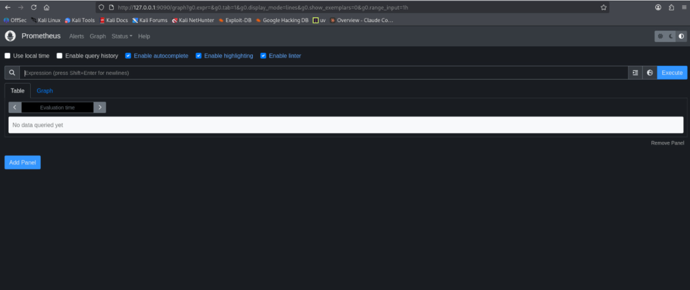

Step 19: Verify the Monitoring Targets
Purpose
Confirm that Prometheus is successfully collecting metrics from all configured monitoring targets.
Procedure
Navigate to:
Status
→ Targets
Expected Result
The configured monitoring targets should display a status of UP, indicating that Prometheus is successfully scraping metrics.
Example:
prometheus UP
node_exporter UP

Verify Targets (UP)
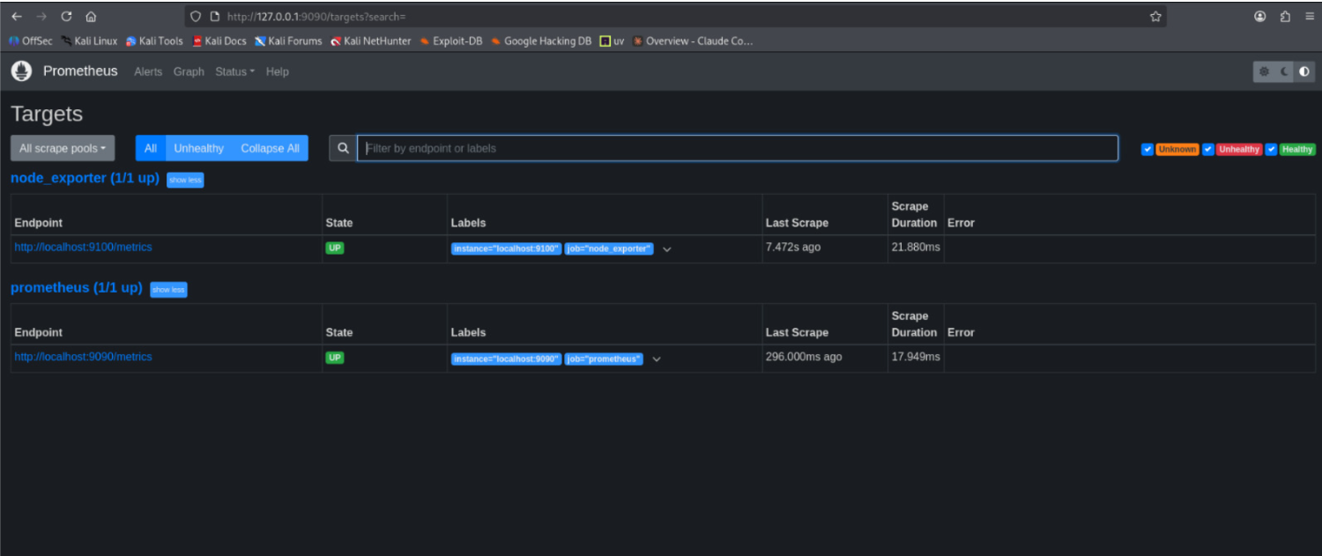

Step 20: Verify Metric Collection
Confirm that Prometheus is successfully collecting metrics from Node Exporter.
Procedure
Open the Graph page and execute the following query:
up
Expected Result
A value of 1 indicates that the monitored target is reachable and that Prometheus is successfully collecting metrics.

Metric Collection Verification
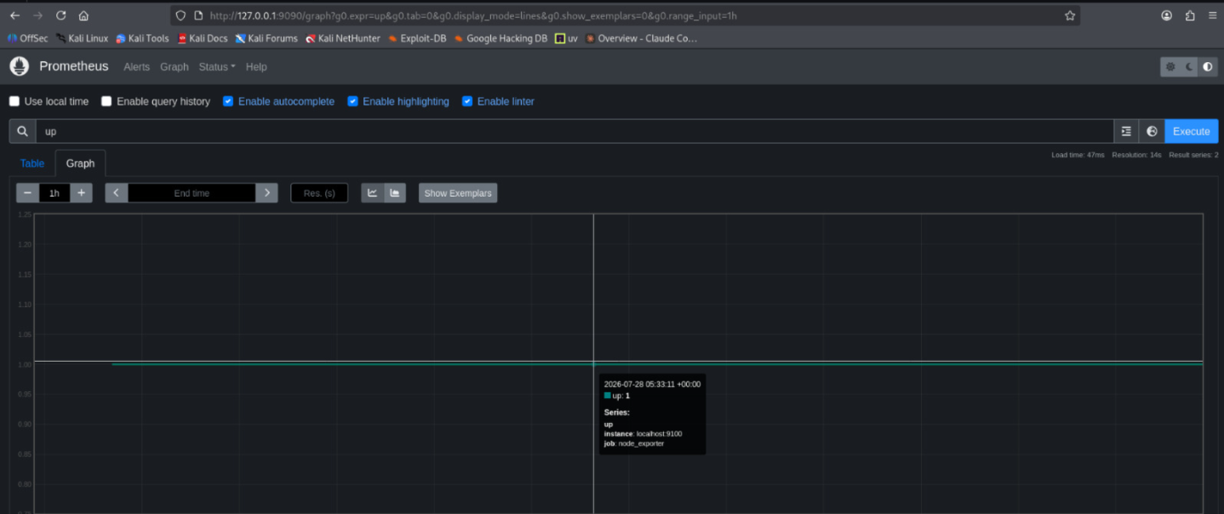
4.8 Summary
This chapter demonstrated the installation and configuration of Prometheus as the central monitoring component of the implementation. The Prometheus binaries were installed, the configuration file was updated to define monitoring targets, and a systemd service was created to ensure the application starts automatically during system boot. Verification through the web interface confirmed that Prometheus was successfully collecting metrics from both itself and the locally deployed Node Exporter service. These collected metrics provided the data source required for creating the monitoring dashboards in Grafana, which are presented in the following chapter.

Chapter 5: Installing and Configuring Grafana

5.1 Objective
Grafana is the final component of the monitoring stack and serves as the visualization platform for the metrics collected throughout this project. While Node Exporter gathers system metrics and Prometheus stores them, Grafana retrieves the stored data from Prometheus and presents it through interactive dashboards. The objective of this chapter is to demonstrate the installation and configuration of Grafana, connect it to Prometheus as a data source, and create dashboards that provide a clear view of system performance and resource utilization.

5.2 Installing Grafana
Why Grafana?
Although Prometheus provides a web interface for viewing collected metrics, the information is presented primarily as raw numerical data. While this is useful for querying individual metrics, it becomes difficult to interpret overall system behaviour or identify trends over time.
Grafana addresses this limitation by transforming the collected metrics into visual dashboards containing graphs, charts, gauges, and statistical panels. These visualizations enable administrators and security analysts to quickly monitor system health, identify abnormal behaviour, and investigate potential performance issues without manually analyzing raw metric values.

Installation
sudo apt update
sudo apt install -y grafana
Verification
grafana-server -v
Expected Output
The command should display the installed Grafana version.

5.3 Starting the Grafana Service
After installation, the Grafana service was started and configured to launch automatically whenever the operating system boots. This ensures that the monitoring dashboard remains available without requiring the service to be started manually after each restart.
Commands
sudo systemctl enable grafana-server
sudo systemctl start grafana-server
Verification
sudo systemctl status grafana-server
The service status should indicate:
Active: active (running)

5.4 Accessing the Grafana Web Interface
Grafana was accessed through a web browser using the default web interface.
http://localhost:3000
or
http://<server-ip>:3000
when Grafana is installed on a remote server.

Upon first login, Grafana prompted for the default administrator credentials before requiring a password change.
Field | Value
Username | admin
Password | admin

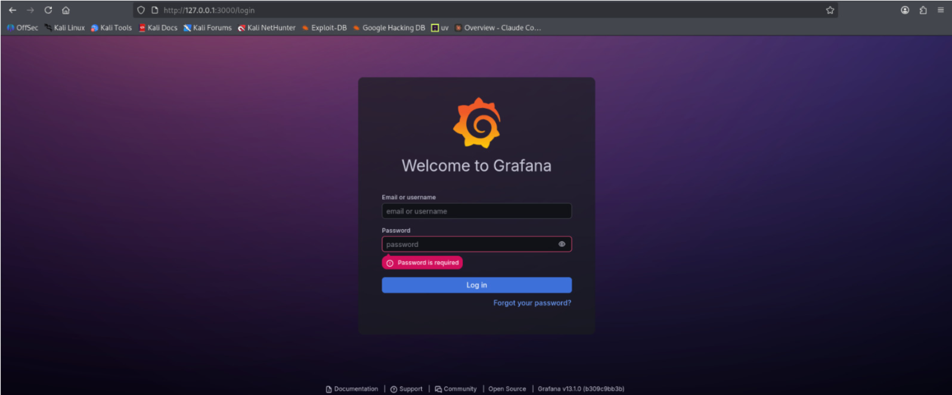
Once authentication was completed, the Grafana home dashboard became available, allowing additional data sources and dashboards to be configured.
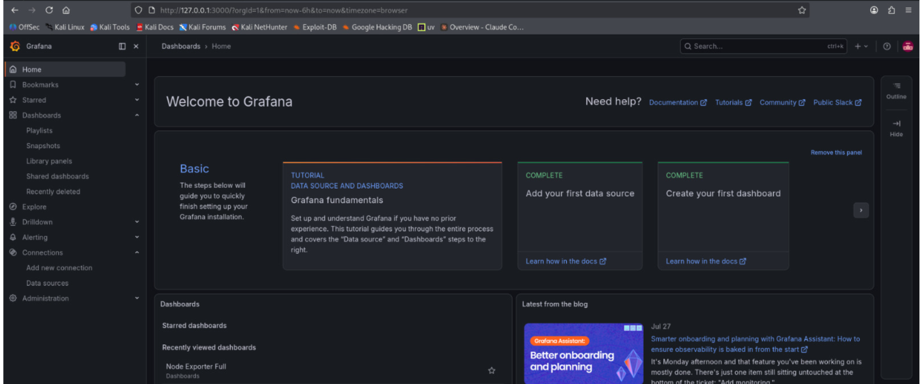

5.5 Configuring Prometheus as a Data Source
Why is a Data Source Required?
Grafana does not collect or store monitoring information on its own. Instead, it retrieves data from external monitoring platforms known as data sources.
During this implementation, Prometheus was configured as the primary data source because it had already been collecting system metrics from Node Exporter. Establishing this connection allowed Grafana to query Prometheus whenever a dashboard was viewed or refreshed, ensuring that all visualizations reflected the most recent system metrics.

Add the Prometheus Data Source
From the Grafana navigation menu, select:
Connections
↓
Data Sources
↓
Add data source
↓
Prometheus
Configure the Connection
Specify the Prometheus server URL.
Setting | Value
URL | http://localhost:9090

5.6 Creating the Monitoring Dashboard
After successfully connecting Grafana to Prometheus, a new dashboard was created to present the collected system metrics in a single monitoring interface.
Instead of viewing individual metrics separately, the dashboard combines multiple visual panels that provide an overview of system performance.
The dashboard developed during this implementation included panels for:
- CPU utilisation
- Memory utilisation
- Disk usage
- Network traffic
- Running processes
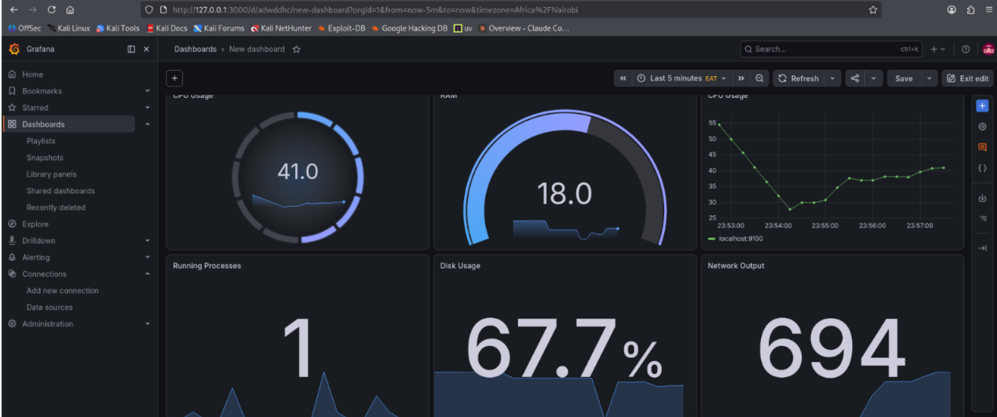

CPU Usage
Purpose
This panel displays the percentage of CPU resources currently being used by the system. Monitoring CPU utilisation helps identify unusually high processor activity that may indicate resource-intensive applications, excessive workloads, or abnormal system behaviour.
PromQL Query
100 - (avg by(instance) (rate(node_cpu_seconds_total{mode="idle"}[5m])) * 100)

Memory (RAM) Usage
Purpose
This panel displays the amount of system memory currently in use. Monitoring memory utilisation helps determine whether the available RAM is sufficient for the running workload and can assist in identifying memory-intensive processes or potential resource exhaustion.
PromQL Query
100 * (1 - (node_memory_MemAvailable_bytes / node_memory_MemTotal_bytes))

Disk Usage
Purpose
This panel displays the percentage of disk space currently in use on the monitored system. It helps administrators monitor storage capacity and identify situations where limited disk space could affect system performance or application availability.
PromQL Query
100 * (
1 -
(
node_filesystem_avail_bytes{fstype!~"tmpfs|overlay"}
/
node_filesystem_size_bytes{fstype!~"tmpfs|overlay"}
)
)

Network Output
Purpose
This panel monitors the rate at which data is transmitted through the network interface. Observing network output helps identify periods of increased outbound traffic, which may be associated with normal system activity, large data transfers, or unusual network behaviour requiring further investigation.
PromQL Query
rate(node_network_transmit_bytes_total{device!="lo"}[5m])

Running Processes
Purpose
This panel displays the total number of processes currently running on the monitored system. Monitoring active processes provides a general indication of system activity and may help identify unexpected increases that could warrant further investigation.
PromQL Query
node_procs_running

5.7 Dashboard Verification
Once all panels had been configured, the dashboard provided a consolidated view of the monitored system.
The dashboard displayed real-time information retrieved from Prometheus, allowing changes in system activity to be reflected automatically whenever the dashboard refreshed.
Example of full imported dashboard with necessary metrics

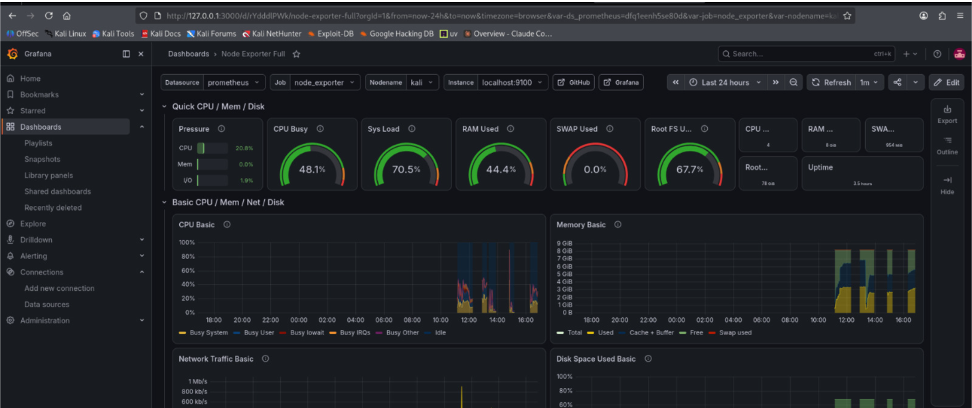

5.8 Summary
This chapter demonstrated the installation and configuration of Grafana as the visualisation component of the monitoring stack. After connecting Grafana to Prometheus, a monitoring dashboard was developed to display key system metrics collected from Node Exporter. The completed dashboard provided a centralized view of system performance, making it easier to monitor resource utilization, identify unusual behaviour, and verify that the monitoring stack was operating as expected.

Chapter 6

Conclusion
This implementation successfully demonstrated the deployment of a complete monitoring stack consisting of Node Exporter, Prometheus, and Grafana within a Kali Linux environment. Each component played a distinct role: Node Exporter collected system metrics, Prometheus stored and managed the collected data, and Grafana transformed the information into meaningful visual dashboards. Together, these components provided an effective platform for monitoring system performance and resource utilization.
Beyond completing the installation, the project also involved configuring services, verifying communication between components, troubleshooting connectivity and data collection issues, and designing dashboards that presented meaningful performance metrics. Working through these challenges reinforced the importance of verifying each stage of the deployment process and demonstrated how the different components interact to provide continuous monitoring.
The completed monitoring stack can support system administrators and Security Operations Centre (SOC) analysts by providing greater visibility into system health and operational performance. When combined with logs, alerts, and other security telemetry, the monitoring platform can contribute to faster issue detection, improved troubleshooting, and more informed operational decision-making.

